**Lesson 13: Exponents**

**Do Now:**

Fill in numbers above each question mark.

1. 16

4 25

9 36

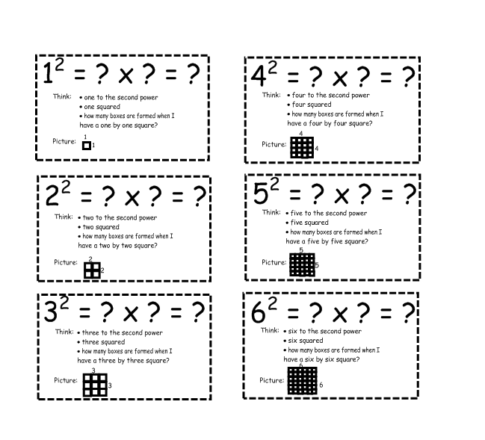

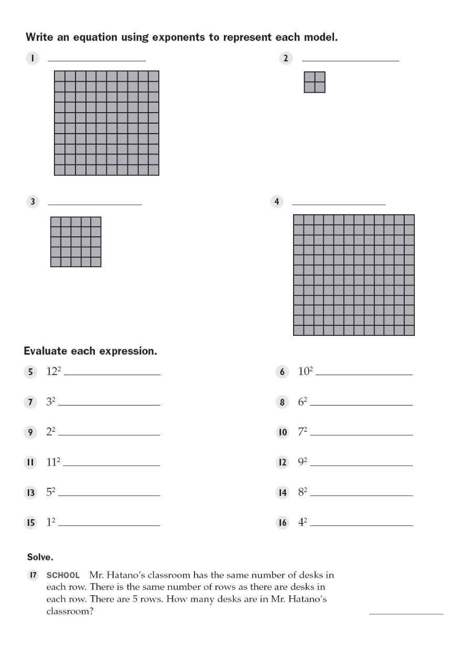

102 22

52 122

144 100

9 36

4 49

121 81

25 64

1 16

25